Publication and Citation Patterns in Scientific Production for Decision-Making: Methods, Indicators, and Tools

Abstract. In the last years, different bibliometric methods and indicators, data mining techniques and collection and visualization tools have been presented for the analysis of publication and citation patterns of scientific production, as well as some criteria and strategies for the acquisition of bibliographic databases that allow forming a knowledge base for decision making, however, they are scattered. In this context, the aim is to determine whether the discovery of publication and citation patterns are being used to perform a methodological analysis of scientific production in order to assist the decision-making process regarding the subscription/acquisition of bibliographic databases in university libraries. Arlene Fink's methodology was applied in conjunction with the PICO structure for the literature review, which allowed selecting relevant information from 2016-2020 obtaining 167 articles for their respective metadata analysis and content analysis through findings matrix. Among the main results of the study, it is necessary to highlight that citation analysis, the number of citations and the VOSviewer collection and visualization tool have been the most outstanding for the analysis of scientific production, although the same have not been used to assist the process of acquisition/subscription of bibliographic databases.
.
Keywords: Publication patterns, Citation patterns, Acquisition criteria, Subscription criteria, Bibliometric, Indicators, Data Mining Tools, Techniques.
- Introduction
In the last five years, bibliometric studies have increased significantly, evaluating the products of scientific communication [1], through statistical and mathematical methods. As a result of these studies, publication and citation patterns are obtained, which can then be used in decision-making. Around the world, these bibliometric studies have been used for decades to measure scientific activity and its impact, and Latin America is not the exception [2, 3, 4, 5]. For example, in Mexico, Guerrero-Sosa et al. presented a system to measure the productivity and impact of publications using bibliometric indicators, metadata, and semantic textual similarity [6]. In Ecuador, Zhimnay et al. analyzed the importance of measuring science to evaluate the academic excellence of universities [7]. Bibliometrics has also been used to improve collection management. In Russia, Gureev and Mazov built a bibliographic collection according to user needs [8]. In Belgium, Siguenza-Guzman et al. evaluated the importance of the library collection by combining four types of pattern analysis: publications, the journals where the institution's professors/researchers publish and their collaborations; citations, the references cited in those publications; downloads, statistics of journals consulted and downloaded provided by database providers; and, impact factor, the importance of a journal when establishing rankings by specialty [9]. Additionally, to increase the value of bibliometric studies, data mining techniques have been introduced through tools that allow the collection, analysis, and visualization of scientific production. They are based on bibliographic mapping and clustering techniques to develop network maps, such as citation-based author networks, co-citations, and bibliographic coupling [10].
Therefore, the use of publication and citation patterns for decision-making has become a fundamental element. Some journals carry out this type of study to find publication trends by studying authorship and citation patterns, analyzing links and connections between institutions, countries/territories, and research areas [11, 12, 13]. This to know how the journal develops and where it should go. Furthermore, there are many studies to determine the productivity of research in a particular field, finding open or restricted access journals, years, journals and institutions that published the most, collaboration networks between authors, etc. Finally, the use of publication patterns and citations for collection management aims to determine which resources (e.g., journals, bibliographic databases, repositories) are the most used by researchers, thus providing information for collection maintenance.
The objective of this study was to investigate and establish which methods, bibliometric indicators, data mining techniques and collection and visualization tools have been the most employed for the discovery of publication and citation patterns in the analysis of scientific production. And if they are being used to support the decision making process regarding bibliographic database subscription/acquisition in university libraries. This article is structured as follows. The second section, the methodology used for the systematic literature review is presented. The third section presents the results obtained and their respective discussion, in which the metadata analysis and descriptive analysis are detailed. Finally, the last section presents the conclusions and findings that will contribute to science and future research related to the subject.
- Methodology
In this literature review, the methodology proposed by Arlene Fink [15] was applied. This procedure allowed for a structured and focused systematic review for research purposes. Finks’ method consists of seven steps: (1) selection of research questions, (2) selection of bibliographic databases, (3) selection of search terms, (4) application of practical detection criteria, (5) application of methodological detection criteria, (6) development of the review, and (7) summary of the results.
The initial step is the selection of research questions answered through the analysis of the information. For this step, the PICO structure was used to design study questions and, at the level of systematic reviews, to develop search strategies that allow delimiting the objective of the study [14, 38]. The name stands for Population where the problem is identified, which for the current study analyzes whether the decision to acquire bibliographic databases in university libraries is based on a methodological analysis of the scientific production generated by the institution through the discovery of publication and citation patterns. Intervention where the intervention criteria are established in which the methods/strategies/criteria of acquisition and subscription, use of bibliometric methods and indicators, data mining techniques and tools for the collection and visualization of scientific production are defined. Comparison between the terms mentioned above and Result of the analysis hope to get the most relevant criteria in terms of acquisition of bibliographic bases, bibliometric methods and indicators, data mining techniques, most used tools for the analysis of scientific production with the discovery of publication and citation patterns and if these patterns have been used as a source for the decision making process in relation to the acquisition and subscription of bibliographic databases. Consequently, the following questions were considered: (a) What are the criteria, methods, or strategies for acquiring bibliographic databases in university libraries? (b) What bibliometric methods are used for the discovery of publication patterns and citations? (c) What are the most used bibliometric indicators for the analysis of publication patterns and citations? (d) What are the most commonly used data mining techniques for analyzing publication and citation patterns? (e) What tools for the collection and visualization of scientific production are used to analyze publication patterns and citations?
The second step corresponded to the selection of bibliographic databases to consult. This step was carried out through a bibliographic search, and resources such as books, scientific journals, websites, and bibliographic databases were considered. This study focused on two bibliographic databases: Scopus, of great international relevance and Scielo which stands out in the hispanic region allowing a more complete study. Subsequently, as a third step, it was necessary to determine the keywords, which, for this research, were derived mainly from the following basic terms: "Acquisition and Subscription", "Bibliometric Methods and Indicators", "Data Mining Techniques and Visualization Tools". The detail of the bibliographic databases, search terms, and the number of results obtained is shown in Table 1.
Table 1. Search terms utilized for the literature review.
Query | Scopus | Scielo
("Acquisition" OR "Subscription") AND "e-journals" AND "University Libraries" | 9 | 0
"Bibliometric Methods" AND (“Publication Patterns” OR "Citation Patterns") | 22 | 1
"Bibliometric Indicators" AND (“Publication Patterns” OR "Citation Patterns") | 36 | 25
"Analysis" AND "Scientific Publications" AND "Data Mining" AND "Techniques" | 11 | 0
("Collection Tool" OR “Visualization Tool”) AND (“Publication Patterns” OR "Citation Patterns" | 47 | 16
TOTAL | 125 | 42

The fourth step was applying practical screening criteria since a large number of articles were obtained in the preliminary searches. In this case, several articles did not contain relevant information for this study when using the search terms. In addition, the selected information was considered for a review if it was published in the 2016-2020 period. Additionally, only articles published in Spanish and English were selected. The Spanish language made it possible to find principles, guidelines, and indicators applied in local institutions. English is the universal scientific language [16]; therefore, it is considered essential in all investigation.
By applying the practical criteria, it was defined that only item-type documents would be reviewed. The result was 167 documents, 5.4% (9 out of 167) corresponded to the search criteria of subscription to digital databases, 6.6% (11 out of 167) to data mining techniques, 13.8% (23 out of 167) to bibliometric methods, 36.5% (61 out of 167) to bibliometric indicators, and 37.7% (63 out of 167) to tools for collecting and visualizing scientific production.
Once the information has been selected, the fifth step was the application of the methodological selection criteria. This step establishes the review of the methodology, results, and conclusion sections of the article to find criteria for acquisition or subscription to digital databases, methods used for bibliometric analysis and bibliometric indicators, data mining techniques, and software tools used for the extraction and visualization of scientific production. To compile the results, the use of a "Findings Matrix" was required, which has the function of listing essential data after implementing the practical and methodological filter. This matrix contains strategic information such as the publication year, the author's name, the title of the document, the content information, research area, abstract, and conclusions. It was used to perform a quick content analysis that helped determining if the articles contain relevant information to the research.
The sixth step corresponded to the study of the selected literature. For this, each document was reviewed in order to identify the information that allowed answering the questions posed in the first step.
Metadata analysis and content analysis will be used. Because metadata analysis is an approach to improve the accuracy of resource discovery, it allows information to be organized in a structured way [39], a range of criteria and procedures may be necessary for different types of metadata. It supports content analysis that will contribute to developing a dialogue about assessing the quality of the metadata [40] and whether it meets the purpose and objectives of the selected study.
So finally, the results were formulated in the seventh step. The data was exported to a spreadsheet for content and metadata analysis. For the content analysis, several sections were established within the matrix according to the intervention criteria in the PICO methodology, in addition to those already established above. With the objective of finding criteria and strategies for the acquisition of digital bases, methods and bibliometric indicators with their respective description and main characteristics. Also, for the metadata analysis a descriptive statistical study was carried out for the latter through the information frequencies, such as year of publication, productivity by country, research area, bibliometric methods and bibliometric indicators, and collection and visualization tools.
- Results and Discussion
In this section, the main findings obtained from the systematic literature review are specified, whose results allowed to know the better state of the art on the use of methods, indicators, and tools for the discovery of publication and citation patterns.
  - Metadata Analysis
The metadata of the reviewed articles provided statistics such as productivity per year, by country, and research area. The results are detailed below.
Concerning the first metadata analysis, this began with the criteria of purchase or subscription to digital databases, where it is observed that few studies have been carried out. There is productivity of 44.4% (4 out of 9) in 2020, 33.3% (3 out of 9) in 2019, 11.1% (1 out of 9) in 2018 and 2017, respectively. The country with the most publications is India with 33.3% (3 out of 9), followed by Nigeria and the United States with 22.2% (2 out of 9), Taiwan and Canada with 11.1% (1 out of 9). Figure 1 shows the productivity by country mentioned above.
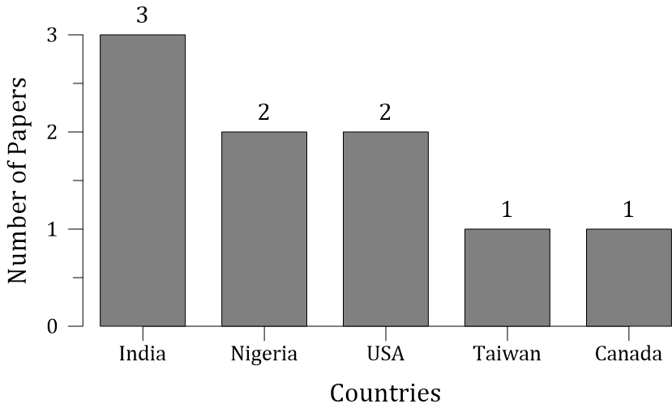
Fig. 1. Amount of information retrieved on purchasing and subscription criteria per country.
Regarding bibliometric methods and indicators, the publications in Scopus and Scielo are distributed as follows. With 23.9% (20 out of 84) of the year 2020, 22.6% (19 out of 84) of the year 2019, 20.2% (17 out of 84) in 2018, 15.4% (13 out of 84) in 2017 and 17.9% (15 out of 84) in 2016. These results reflect an increase in the number of studies published year after year. Figure 2 shows the most prolific countries according to Scopus, China 13.8% (8 out of 58) and India 10.3% (6 out of 58). In Scielo, Cuba stands out with 26.9% (7 out of 26).

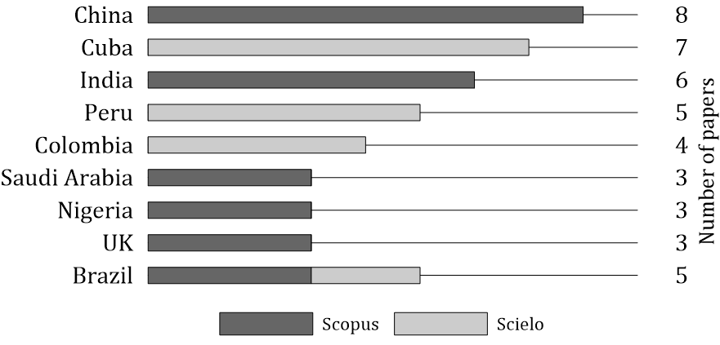
Fig. 2. The number of publications of bibliometric methods and indicators by country in Scopus and Scielo.
The research areas to which the studies of bibliometric methods and indicators have been directed both in Scopus and Scielo can be seen in Figure 3. In Scopus, the area of Health Sciences stands out with 25.9% (15 out of 58), followed by Scientometrics with 22.4% (13 out of 58) and Engineering with 17.2% (10 out of 58). Regarding Scielo, the results confirm Health Sciences and Scientometrics as the most relevant with 34.6% (9 out of 26) and 19.2% (5 out of 26), respectively.
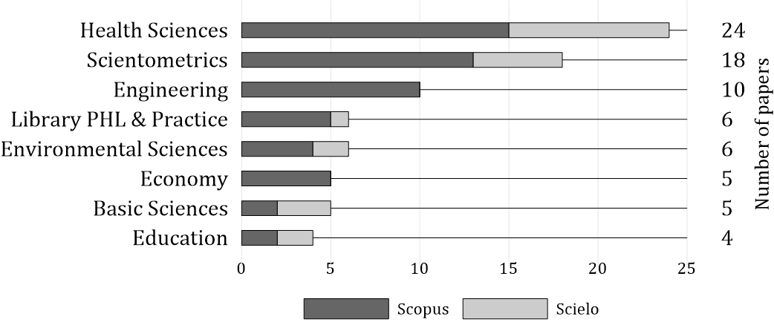
* PHL = Philosophy
Fig. 3. Scopus and Scielo research areas on bibliometric methods and indicators.
Within the Health Sciences, topics such as Oncology [17], Complementary Medicine [18], and Orthopedics [19] are treated. Bibliometric studies are carried out on these topics seeking to obtain years of greater production, outstanding authors, the origin of authors, among others [20]. It is followed by Scientometrics, which develops activities such as publication trends [11] and analysis of the kinetics of self-citations of a journal [21], the international scientific collaboration of researchers [22], mapping of scholarly communication in publications [22], preprints such as accelerator of scholarly communication [23], text analysis [24], measurement and visualization of collaboration and research productivity [25], research impact and country productivity [26]. Finally, one of the three relevant areas is Engineering, including topics related to the comparative analysis of citation patterns in mechanical and civil engineering research projects [27].
A small number of publications explicitly mention the use of data mining techniques such as clustering, classification, or association rules. The productivity of publications per year in Scopus is described below, with 27.3% (3 out of 11) in 2020, 18.1% (2 out of 11) in 2019, 27.3% (3 out of 11) in 2018, 9.1% (1 out of 11)) in 2017 and 18.2% (2 out of 11) in 2016, becoming a still little explored field for research studies related to publication and citation patterns. Scielo's results are null. Regarding productivity by country, Spain stands out with 18.2% (2 out of 11).
Finally, the use of tools to compile and visualize scientific production in bibliometric studies has been remarkable. Scopus reflects in 2020 a productivity of 31.9% (15 out of 47), 23.4% (11 out of 47) in 2019, 19.1% (9 out of 47) in 2018, 17% (8 out of 47) in 2017 and 8.5% (4 out of 47). 47) in 2016. These results are closely related to those ones presented at the beginning of this section since they use at least one collection and visualization tool to carry out these studies. Figure 4 presents the most prolific Scopus and Scielo countries. In Scopus, the United States stands out with 25.5% (12 out of 47), China with 12.8% (6 out of 47), and India with 10.6% (5 out of 47). The results related to Scielo have productivity of 6.3% (1 out of 16) in 2020, 31.3% (5 out of 16) in 2019, 25% (4 out of 16) in 2018, 31.3% (5 out of 16)) in 2017 and 6.3% (1 out of 16) in 2016. Likewise, as shown in Figure 4, the country with the most publications is Brazil with 81.2% (13 of 16), high above Argentina, Mexico, and Singapore with a productivity of 6.3% (1 of 16), respectively. Scielo is a more local digital library in Latin America; therefore, there is a considerable difference concerning productivity with Scopus, a global database. This allows concluding that there is still a gap in research with other countries despite the work done in Latin America.
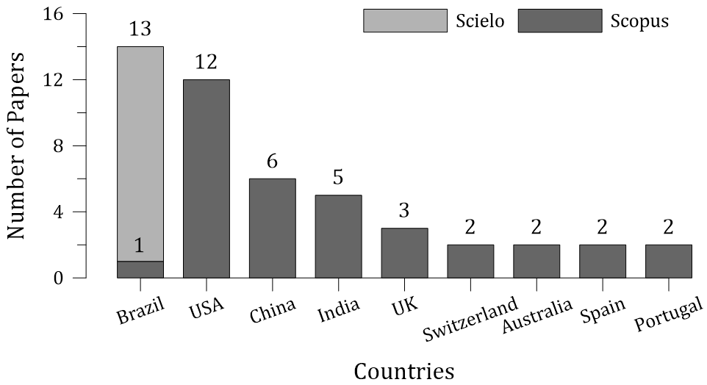
Fig. 4. Amount of information in Scopus and Scielo on collection and visualization tools.
  - Content Analysis
In the content analysis, the research questions established in Section 2 are answered. Regarding the question: 1) What are the criteria, methods, or strategies for acquiring digital databases in university libraries? Previously, the articles describing the entities or institutions that subscribe or acquire a digital repository were located. The articles focus on the assessment of the availability of digital resources and library services [28], mention knowledge management for the development of collections [29], and emphasize providing and maintaining access to electronic journals [30].
The most relevant strategies for acquiring or subscribing to digital databases are formalizing and strengthening the links between undergraduate students and library staff to improve access to information [28], networking, cataloging, classification, and exchange of information materials [31]. Another strategy consists on selectors, i.e., library personnel who possess a great deal of tactical knowledge and subject areas, in addition to knowing which books or journals are of interest and which formats are preferred [29]. Likewise, an additional strategy is the formation of consortia between libraries where each has a representative participating in decision-making for the consortium's collection [30]. It is important to mention that all this can be a challenge for those who have not been directly involved if they do not know about purchasing, licensing, negotiations with suppliers, budget planning, and policy creation [29].
Regarding the research questions, 2) What bibliometric methods are used to discover publication and citation patterns, and 3) What are the most used bibliometric indicators for the analysis of publication and citation patterns? For their evaluation, the frequency of the different bibliometric methods and indicators was analyzed. Regarding bibliometric studies, Web of Science was the primary data source used with 51.7% (30 out of 58), followed by Scopus with 29.3% (17 out of 58), PubMed, and Medline with 5.2% (3 out of 58), respectively.
Regarding the bibliometric methods in Scopus, Table 2 shows that citation analysis stands out with 27.6% (16 out of 58), which allows determining links and connections in research works [32], co-citation analysis with 10.3% (6 out of 58) recognizing the affinity between co-cited authors [33], co-words analysis with 10.3% (6 out of 58) mapping the conceptual structure and thematic of a specific domain [34]. Additionally, either Lotka's Law, Bradford's Law, and Zipf's Law equally represent 6.9% (4 out of 58) of the bibliometric methods used in the literature. Lotka's Law describes the quantitative relationship between authors and articles produced in a given field and period [35]. Bradford's Law allows the selection of publications and is the most productive and relevant to cover a given area of ​​knowledge [36]. Finally, Zipf's Law provides mechanisms to identify and select keywords in a text [37].
Table 2. Bibliometric methods utilized in the literature.
Bibliometric Method | # of articles
Citation analysis | 16
Co-citation analysis | 6
Co-words analysis | 6
co-authorship analysis | 5
Lotka's Law | 4
Bradford's Law | 4
Zipf's Law | 4

As it can be seen in the Scopus results in Table 3, the number of citations stands out with 37.9% (22 out of 58) as the most used bibliometric indicator, followed by the number of articles with 25.9% (15 out of 58), the number of authors with 20.7% (12 out of 58), the h-index with 18.9% (11 out of 58), the impact factor with 13.7% (8 out of 58) and the citation score with 5.2% (3 out of 58). Likewise, for the bibliometric analysis, the publications metadata are extracted, such as author, subject, country, institution, journal, year of publication, category, language, affiliation, and title. The results corresponding to Scielo are also presented, in which the number of articles with 80.8% (21 out of 26) stood out, followed by the number of citations with 65.4% (17 out of 26) and the number of authors with 53.9% (14 out of 26). These results ratify those presented in Scopus, which determines the number of articles and citations as the most relevant.
Table 3. Bibliometric Indicators Scielo y Scopus
Bibliometric indicator | Scopus | Scielo
Number of articles | 15 | 21
Number of citations | 22 | 17
Number of authors | 12 | 14
h-index | 11 | 7
Impac factor | 8 | 5
CiteScore | 3 | 3

Regarding question 4) What are the most used data mining techniques for analyzing publication patterns and citations? Data mining techniques are usually used to find hidden information in big amounts of data [41]. It can be applied to different areas, for example, Torres Berrú et al. presents a study whose purpose is to find algorithms that identify specific characteristics of fraud or corruption with the analysis of a set of documents with related topics [42]. On the other hand, Marcos-Pablos et al. describes a methodology with the objective of helping to adapt, filter and synchronize the search and selection of articles for bibliographic reviews, taking as a study set the abstracts of scientific databases. In both cases the main tool is data mining techniques [43]. From the articles, a list of data mining techniques is obtained between the second, third, and fourth search terms for Scopus since no results on this topic were found in Scielo. The findings show that clustering stands out with 11.6% (8 out of 69), classification with 10.1% (7 out of 69), and multiple regression with 5.8% (4 out of 69), these percentages being relatively low. However, the next question shows the use of tools dedicated exclusively to bibliometric studies that include data mining functionalities.
Finally, on the research question, 5) What tools for the collection and visualization of scientific production are used to analyze publication and citation patterns? To identify the collection and visualization tools, the total number of documents obtained from Scopus was taken from the search terms of bibliometric methods and indicators, together with the term of collection and visualization tools, giving a total of 105 documents. The tools that stand out in data collection are HistCite with 4.8% (5 of 105), CiteSpace with 2.9% (3 of 105), ScientoPy with 1.9% (2 of 105), and Endnote with 1.9%. For the visualization tools, Excel was found with 20.9% (22 of 105), Tableau, DAVID, SPSS, Sci2, Ucinet, and Pajek, all with a percentage of 1.9% (2 of 105), respectively. Finally, the most used tool for both collection and visualization with 28% (29 out of 105) is VOSviewer since it is a software tool to build and visualize bibliometric networks. These networks can include, for example, individual journals, researchers or publications, and can be created based on citations, bibliographic links, co-citations, or co-authorship relationships [44, 45]. VOSviewer also offers data mining functionality to build and visualize co-occurrence networks of important terms drawn from a body of scientific literature [46]. Table 4 shows the collection and visualization tools found in Scopus that stood out the most. Regarding Scielo, the tools that stand out in data collection and visualization are Excel with 45.2% (19 of 42), VOSviewer with 14.3% (6 of 42), EndNote with 9.5% (4 of 42), and Cochrane with 7.1 % (3 of 42), shown in Table 5.
Table 4. Collection and Visualization tools reported in Scopus.
Tool | Number of articles
VOSviewer | 29
Excel | 22
HistCite | 5
CiteSpace | 3
Pajek | 2
ScientoPy | 2
EndNote | 2

Table 5. Collection and Visualization tools reported in Scielo.
Tool | Number of articles
Excel | 19
VOSviewer | 6
EndNote | 4
Cochrane | 3
SPSS | 3
Ucinet | 3
NetDraw | 2

- Conclusions
This article describes a systematic review with the objective of establishing the most commonly used bibliometric methods and indicators, data mining techniques, and collection and visualization tools for the discovery of publication and citation patterns. In addition to determine if these are being used in the decision making process in university libraries regarding the subscription/acquisition of bibliographic databases. In this work, the PICO structure and Fink's model of research literature review were applied based on a definition of research questions that allowed identifying resources related to the research topic [7]. In the first part of the literature review, a searching for information was developed in two digital databases (Scopus and Scielo). Later, practical and methodological selection criteria were applied which established a sample of 167 articles with scientific content for their analysis.
Through the development of this review, it was determined that the ability to use publication and citation patterns for collection management has not been exploited, specifically to decide which journal, database, or repository to acquire or subscribe, a decision that academic libraries must constantly occupy. As can be seen, these decisions are made by staff with a high degree of knowledge in licensing, budget planning, etc. However, if there were another way on which to support such decisions, it would make the analysis more objective and thus improving the maintenance of the collections.
The next point corresponds to the bibliometric methods, which stand out, the citation analysis allowing to determine links and connections in the research work; the co-citation analysis that recognizes the affinity between cited co-authors; and, finally, the study of common words mappings the conceptual and thematic structure of a specific domain. These methods are valuable because, after a certain process, they result in co-authorship maps, cross-country comparisons, connections between research topics, i.e., a lot of information to analyze. However, in order to apply these methods, the unit of measurement called "bibliometric indicator" is necessary. Also, the most important aspect in this study is the number of citations, number of articles, and H-index which allow evaluating different characteristics of science activity linked to both the production and the consumption of information.
Bibliometric studies have increased considerably; thus, there are a series of tools that facilitate this activity. VOSviewer is the most used not only for the collection and visualization of information but also for data mining capabilities. In addition, Excel should be considered a key tool that can be regarded as unique because, depending on the topic this works with, it adapts to the needs of users, ranging from data management, calculations with information to visualization of summary of results by graphs.
This work can be seen as an initial conceptual framework for developing research projects and the construction of new tools for the analysis of scientific production. Therefore, as future work, it is recommended to create a software or tool that allows uniting these methods, indicators, and tool functionalities whose objective is to provide information for decision-making in university libraries for collection maintenance.

Appendix A – Full list of references retrieved in the literature review from Scopus and Scielo
The list of sources used in the literature review can be found online at https://n9.cl/ctdhg.

References
- Solis, B.P., Argüello, J.C.C., Barba, L.G., Gurrola, M.P., Zarhri, Z., TrejoArroyo, D.L.: Bibliometric Analysis of the Mass Transport in a Gas Diffusion Layer in PEM Fuel Cells. Sustainability. 11, 1–18 (2019)
- Glänzel, W.: Bibliometrics as a research field: A course on theory and application of bibliometric indicators. Course Handouts. (2003)
- González Alcaide, G., Gorraiz, J.I.: Assessment of Researchers Through Bibliometric Indicators: The Area of Information and Library Science in Spain as a Case Study (2001–2015). Front. Res. Metr. Anal. 3, (2018). https://doi.org/10.3389/frma.2018.00015
- Abramo, G.: Bibliometric evaluation of research performance: where do we stand? VO. 112–127 (2017). https://doi.org/10.17323/1814-9545-2017-1-112-127
- Beaudry, C., Larivière, V.: Which gender gap? Factors affecting researchers’ scientific impact in science and medicine. Research Policy. 45, 1790–1817 (2016). https://doi.org/10.1016/j.respol.2016.05.009
- Guerrero-Sosas, J.D.T., Chicharro, F.P.R., Serrano-Guerrero, J., Menendez-Dominguez, V., Castellanos-Bolaños, M.E.: A proposal for a recommender system of scientific relevance. Procedia Computer Science. 162, 199–206 (2019). https://doi.org/10.1016/j.procs.2019.11.276
- Zhimnay, C., Fernández Landivar, J., Albarracín, J., Sadaba, I., Sucozhanay, D.: MAPPING OF SCIENTIFIC PRODUCTION IN SOCIAL SCIENCES IN ECUADOR. Presented at the March 1 (2019)
- Gureyev, V., Mazov, N.: Assessment of the Relevance of Journals in Research Libraries Using Bibliometrics (a Review). Scientific and Technical Information Processing. 42, 30–40 (2015). https://doi.org/10.3103/S0147688215010050
- Siguenza-Guzman, L., Holans, L., Abbeele, A.V.D., Vandewalle, J., Verhaaren, H., Cattrysse, D.: TOWARDS A HOLISTIC ANALYSIS TOOL TO SUPPORT DECISION-MAKING IN LIBRARIES. undefined. (2013)
- Tuppal, C.P., Gallardo-Ninobla, M.M., Arquiza, G.S., Vega, P.D.: A bibliometric analysis of the Philippine Journal of Nursing for 1966 - 2017., https://www.herdin.ph/index.php/herdin-home?view=research&cid=71335
- Ullah, S.: Publication Trends Of Pakistan Heart Journal: A Bibliometric Study. Library Philosophy and Practice (e-journal). (2019)
- Wang, W., Laengle Scarlazetta, S., Merigó Lindahl, J., Yu, D., Herrera Viedma, E., Cobo, M.J., Bouchon Meunier, B.: A Bibliometric analysis of the first twenty-five years of the international journal of uncertainty, fuzziness and knowledge-based systems. Iinternational Journal of Uncertainty Fuzziness and Knowledge-Based Systems. (2018). https://doi.org/10.1142/S0218488518500095
- Peter, M., Samuel, S.A., Idhris, M., Subbarayalu, A.: Saudi Arabian Top Four Medical journals Bibliometric study. Library Philosophy and Practice (e-journal). (2020)
- BA, K., Charters, S.: Guidelines for performing Systematic Literature Reviews in Software Engineering. 2, (2007)
- Fink, A.: Evaluation Fundamentals: Insights into Program Effectiveness, Quality, and Va-lue. SAGE Publications (2014)
- Ramírez, M.G., Falcón, I.A.L.: Importancia Del Lenguaje En El Contexto De La Aldea Global. Horizontes Educacionales. 15, 95–107 (2010)
- Danell, J.-A.B.: Integrative oncology from a bibliometric point of view. Complementary Therapies in Medicine. 52, 102477 (2020). https://doi.org/10.1016/j.ctim.2020.102477
- Danell, J.-A.B., Danell, R., Vuolanto, P.: Scandinavian research on complementary and alternative medicine: A bibliometric study. Scand J Public Health. 48, 609–616 (2020). https://doi.org/10.1177/1403494819834099
- Shon, W.Y., Yoon, B.-H., Jung, E.-A., Kim, J.W., Ha, Y.-C., Han, S.H., Kim, H.-S.: Assessment of Korea’s Orthopedic Research Activities in the Top 15 Orthopedic Journals, 2008-2017. Clin Orthop Surg. 11, 237–243 (2019). https://doi.org/10.4055/cios.2019.11.2.237
- Shi, X., Cai, L., Jia, J.: The Evolution of International Scientific Collaboration in Fuel Cells during 1998–2017: A Social Network Perspective. Sustainability. 10, 4790 (2018). https://doi.org/10.3390/su10124790
- Heneberg, P.: From Excessive Journal Self-Cites to Citation Stacking: Analysis of Journal Self-Citation Kinetics in Search for Journals, Which Boost Their Scientometric Indicators. PLoS One. 11, e0153730 (2016). https://doi.org/10.1371/journal.pone.0153730
- B S, M., Rajgoli, I.: Mapping of Scholarly Communication in Publications of the Astronomical Society of Australia, Publications of the Astronomical Society of Japan , and Publications of the Astronomical Society of the Pacific : A Bibliometric Approach. Science & Technology Libraries. 36, 351 (2017). https://doi.org/10.1080/0194262X.2017.1368427
- Wang, Z., Chen, Y., Glänzel, W.: Preprints as accelerator of scholarly communication: An empirical analysis in Mathematics. Journal of Informetrics. 14, 101097 (2020). https://doi.org/10.1016/j.joi.2020.101097
- Ranaei, S., Suominen, A., Porter, A., Carley, S.: Evaluating technological emergence using text analytics: two case technologies and three approaches. Scientometrics. 122, 215–247 (2020). https://doi.org/10.1007/s11192-019-03275-w
- Leidolf, A., Baker, M., Porter, A., Garner, J.: Measuring and Visualizing Research Collaboration and Productivity. Journal of Data and Information Science. 3, 54–81 (2018). https://doi.org/10.2478/jdis-2018-0004
- Barrot, J.: Research impact and productivity of Southeast Asian countries in language and linguistics. Scientometrics. 110, (2016). https://doi.org/10.1007/s11192-016-2163-3
- Osueke, C.O., Idiegbeyan-ose, J., Botu, T., Aregbesola, A., Emmanuel, O.: Analysis of mechanical engineering research activities using bibliometric method: A case study of undergraduate projects. International Journal of Mechanical Engineering and Technology. 9, 1014–1021 (2018)
- Tukur, L.M., Kannan, S.: An Appraisal of Availability and Utilization of Information Re-sources and Library Services by Undergraduate Students in Three Agriculture University Libraries in Northern Nigeria (ABU, FUAM, FUTM). 27
- J Proctor, J. Knowledge management for collection development: Transforming institutio-nal knowledge into tools for selectors. Serials Librarian, 76(1–4), 118–122. https://doi.org/10.1080/0361526X.2019.1551668. (2019).
- Zhao, W., Zhao, S., MacGillivray, K.-S.: Providing and Maintaining Access to Electronic Serials: Consortium and Member University Library’s Perspectives. The Serials Librarian. 72, 144–151 https://doi.org/10.1080/0361526X.2017.1309831 (2017).
- Babatunde, T., Alhassan, J., Dr, B.: Effective Resource Sharing Services In University Li-braries In North Central Nigeria. (2020)
- Andalia, R.: Los análisis de citas en la evaluación de los trabajos científicos y las publicaciones seriadas. 7, (1999)
- Miguel, S., Moya-Anegón, F., Herrero-Solana, V.: El análisis de co-citas como método de investigación en Bibliotecología y Ciencia de la Información. Investigación bibliotecológica. 21, 139–155 (2007)
- Galvez, C.: Análisis de co-palabras aplicado a los artículos muy citados en Biblioteconomía y Ciencias de la Información (2007-2017). Transinformação. 30, 277–286 (2018). https://doi.org/10.1590/2318-08892018000300001
- Alvarado, R.U.: La ley de Lotka y la literatura de bibliometría. Investigación bibliotecoló-gica. 13, 125–141 (1999)
- Urbizagástegui Alvarado, R., Urbizagástegui Alvarado, R.: El crecimiento de la literatura sobre la ley de Bradford. Investigación bibliotecológica. 30, 51–72 https://doi.org/10.1016/j.ibbai.2016.02.003 (2016).
- Urbizagastegui, R., Restrepo Arango, C.: Zipf’s law and Goffman’s transition point in the automatic indexing. Investigacion Bibliotecologica. 25, 71–92 (2011)

NUEVAS REFERENCIAS
- Shokraneh, F.: PICO Framework: Two Decades of Variation and Application. (2016)
- Chen, Y., Chen, S., Chang, Y., Lin, S.C., Ya-ning, V.-, Shu-jiun, C., Yi-ting, C., Simon, C., Lin, C., Chen, Y., Chen, S., Chang, Y., Lin, S.C.: A Metadata Lifecycle for Content Analysis in Digital Libraries
- Moen, W.E., Stewart, E.L., McClure, C.R.: The Role of Content Analysis in Evaluating Metadata for the U.S. Government Information Locator Service (GILS).
- Alvarez-Jareño, J., Badal-Valero, E., Pavia, J.: Aplicación de métodos estadísticos, económicos y de aprendizaje automático para la detección de la corrupción. 9, (2019)
- Torres Berrú, Y., Batista, V., Torres-Carrion, P.: Data Mining to detect and prevent corruption in contracts: Systematic Mapping Review. RISTI - Revista Iberica de Sistemas e Tecnologias de Informacao. 13–25 (2020)
- Marcos-Pablos, S., García-Peñalvo, F.J.: Information retrieval methodology for aiding scientific database search. Soft Comput. 24, 5551–5560 (2020). https://doi.org/10.1007/s00500-018-3568-0
- Pandey, S., Sahoo, S.: Research Collaboration and Authorship Pattern in the field of Semantic Digital Libraries. DESIDOC Journal of Library &amp; Information Technology. 40, 375
- Sahoo, S., Pandey, S.: Evaluating research performance of Coronavirus and Covid-19 pandemic using scientometric indicators. Online Information Review. 44, 1443–1461 (2020). https://doi.org/10.1108/OIR-06-2020-0252
- Yi, W., Wang, Y., Tang, J., Xiong, X., Zhang, Y., Yan, S.: [Visualization analysis on treatment of coronavirus based on knowledge graph]. Zhonghua Wei Zhong Bing Ji Jiu Yi Xue. 32, 279–286 (2020). https://doi.org/10.3760/cma.j.cn121430-20200225-00200

